Introduction

There are a lot of restaurants in the any single city. The prosperity of a city could directly relate to the variety of types and number of restaurants in a city. As one could imagine Toronto as the major commercial district of Canada. The diversity of its catering options is enormous. The choices are not limited to western cuisines like pizza, burger and sandwich but also Asian cuisines like sushi, dumpling and dim sum.

With this huge assortment of international restaurants, it represents a great opportunity for businessmen regardless of restaurant operators, agricultural product suppliers and equipment suppliers, to tap into this market. Therefore, here comes the question, can we know more about this market as to which type of restaurant is more popular? Would there be any geographical differences when it comes to the operating restaurants in different areas?

Business background

Assuming there is an international restaurant operator who is interested in setting up his very first restaurant in the Toronto. As he owns an expansive and diverse types of international restaurant chain. He is interested in knowing which type of food should he offer in a particular place. In addition, he would like to know the area which has the highest population that could mean the ideal location for his very first store.

Data

To attaint the objective for this businessman, we will to have collect the below data:

1. PostalCode, Borough, Neighborhood and their respective latitude and longitude.
   * We find get the data from scrapping website: <https://en.wikipedia.org/wiki/List_of_postal_codes_of_Canada:_M>
   * We get the latitude and longitude values of the Neighborhood by geopy library which are used as input into Foursquare
   * This is useful to categorize and breakdown the city of Toronto to smaller areas for the ease of our clustering and analysis
2. We deploy Foursquare to generate a list of restaurants close to the location of every neighborhood.
   * We selected the top 200 restaurants within 500m of the neighborhood with the using of API from Foursquare.
   * This would be helpful for us to find the most popular type of restaurant in the city of Toronto and in each neighborhood.
   * With the popular type of restaurants, we can cluster the neighborhood into various groups.
3. We gathered population data of Toronto, latest as of 2016, by Forward Sortation Area (FSA) from the Statistics Canada to show if there is a relationship between population density and the type of popular food in particular area
   * Link: <https://www12.statcan.gc.ca/census-recensement/2016/dp-pd/hlt-fst/pd-pl/Tables/CompFile.cfm?Lang=Eng&T=1201&OFT=FULLCSV>
4. To create a choropleth map of Toronto, we also need a geojson file
   * This helps to create a handy tool to visualize the population density in each area
   * Link: <https://github.com/BlizzWiz/IBM_Capstone_Project/raw/master/toronto_m.geojson>

Data processing and cleansing

1. We used Beautifulsoap 4 as a web scraping package to get the neighborhood data and combined it with the latitude and longitude values from geopy package.
2. We removed values that contain null or not assigned.

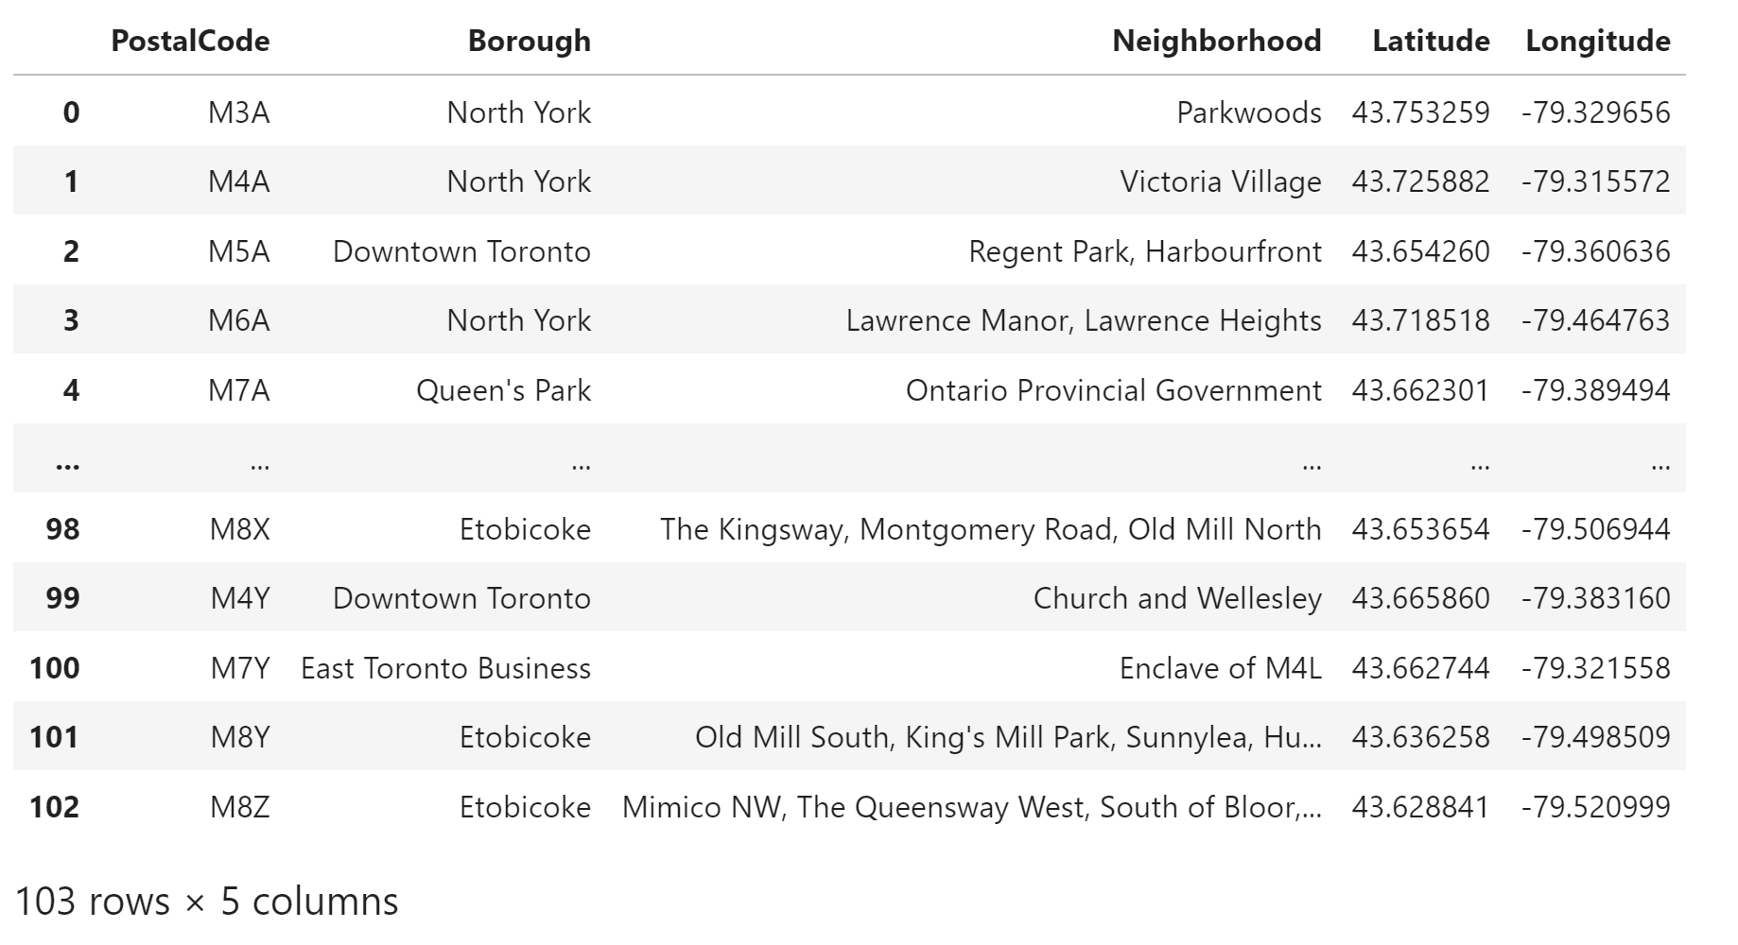

1. Then we downloaded the all restaurants near each neighborhood via Foursquare API.

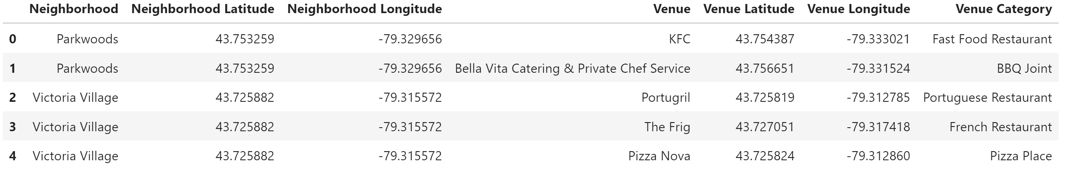

1. We downloaded the population data from Statistics Canada and extracted the useful columns such as geographic code, province and population data. Then we extracted the data that are related to Ontario only.

Explanatory data analysis

1. After we retrieved the restaurants close to every neighborhood, we implemented onehot encoding to the dataframe.
2. We get the total number of store per type of restaurants and sort by top 20 most popular restaurants

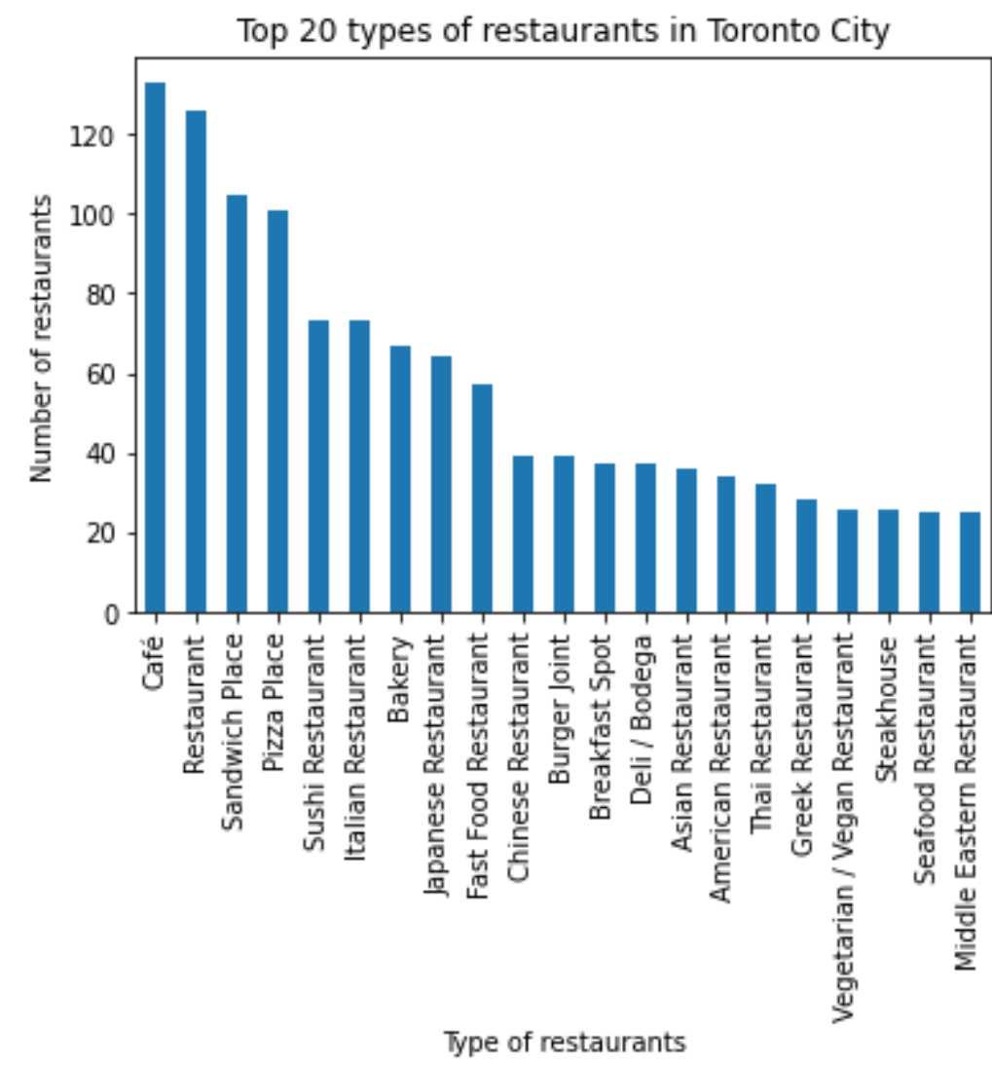

1. We then group the dataframe by neighborhood and see which neighborhood has the most number of restaurants
2. 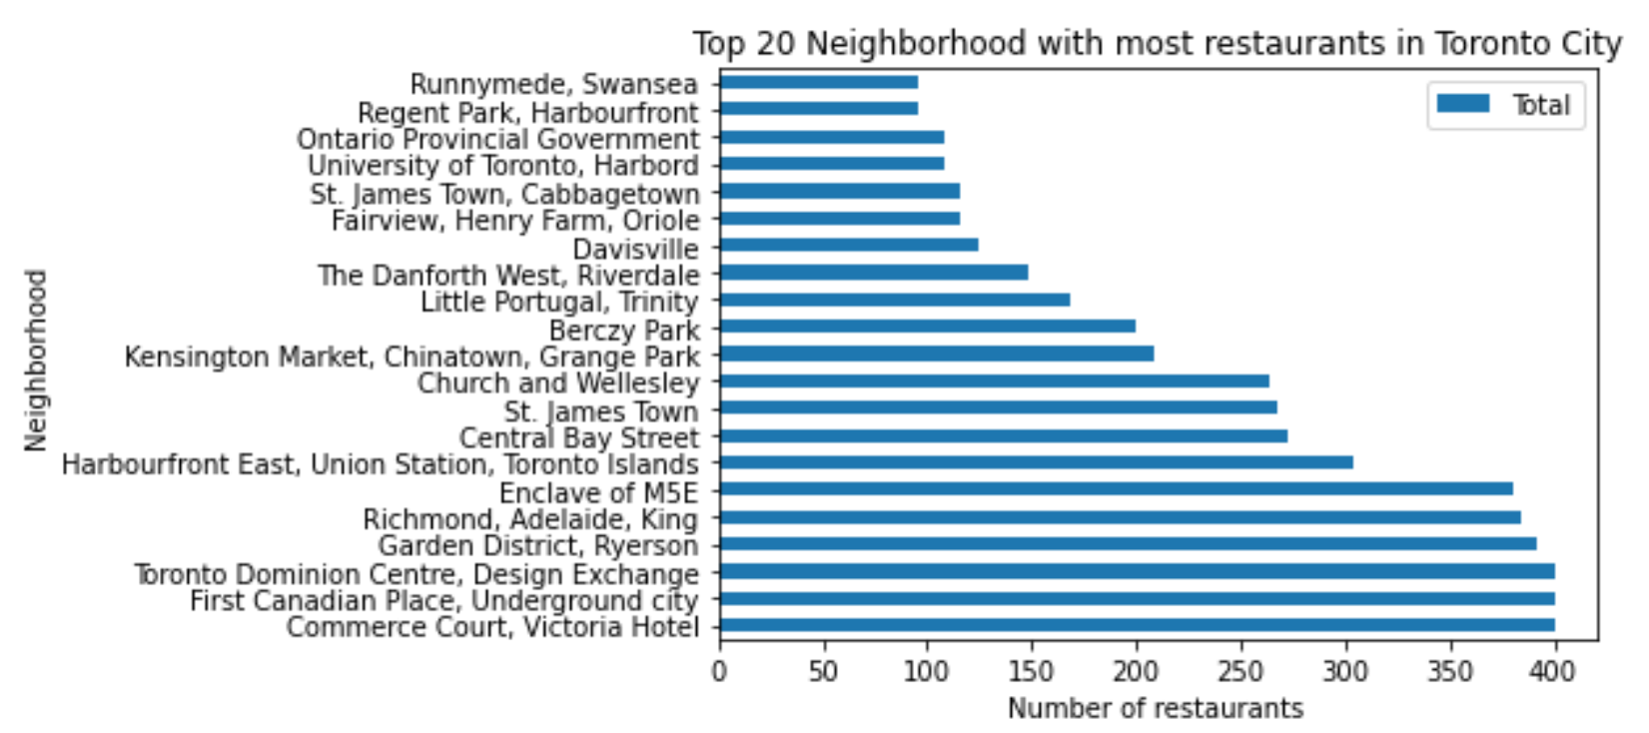
3. We also generate a dataframe that rank the top 10 popular restaurants in each neighborhood

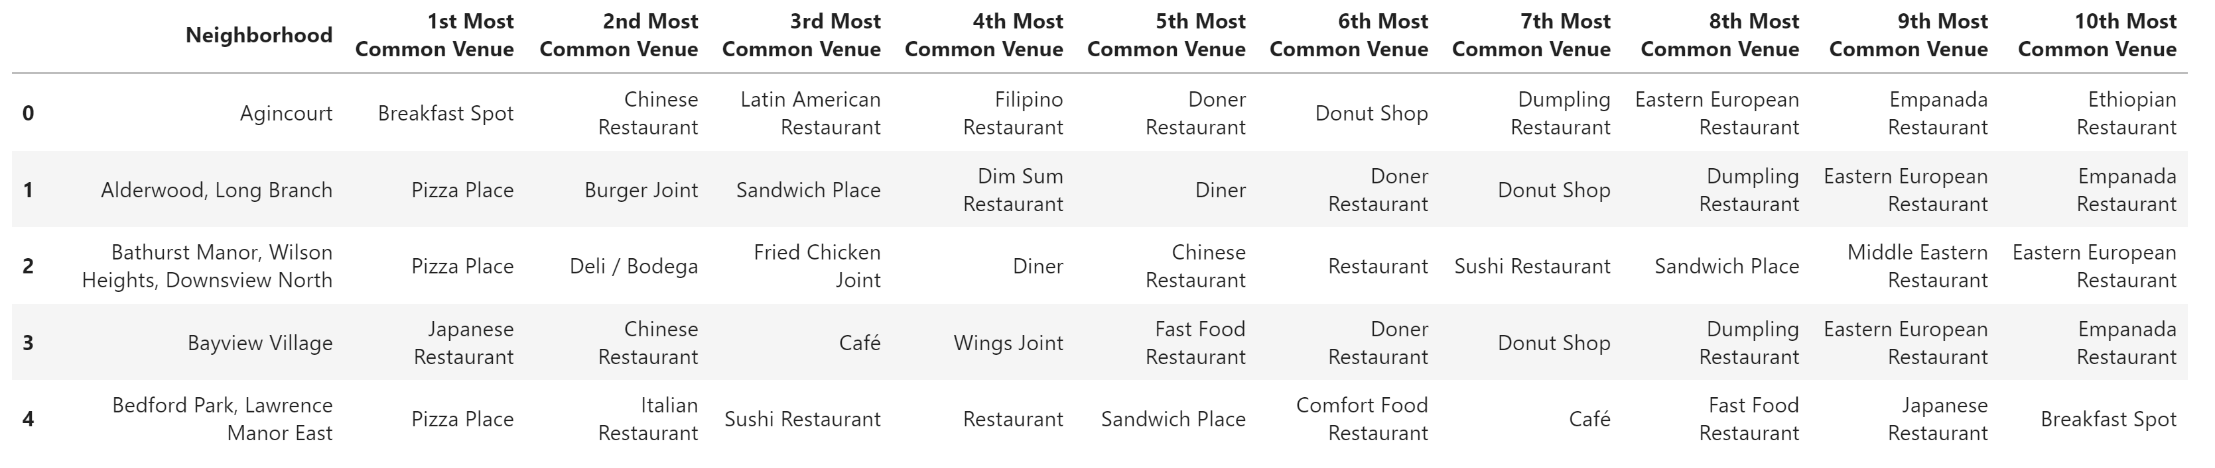

1. After importing the population data from Statistic Canada, we generated a Choropleth map showcasing the population density by FSA with the help of folium and Toronto’s geojson file.

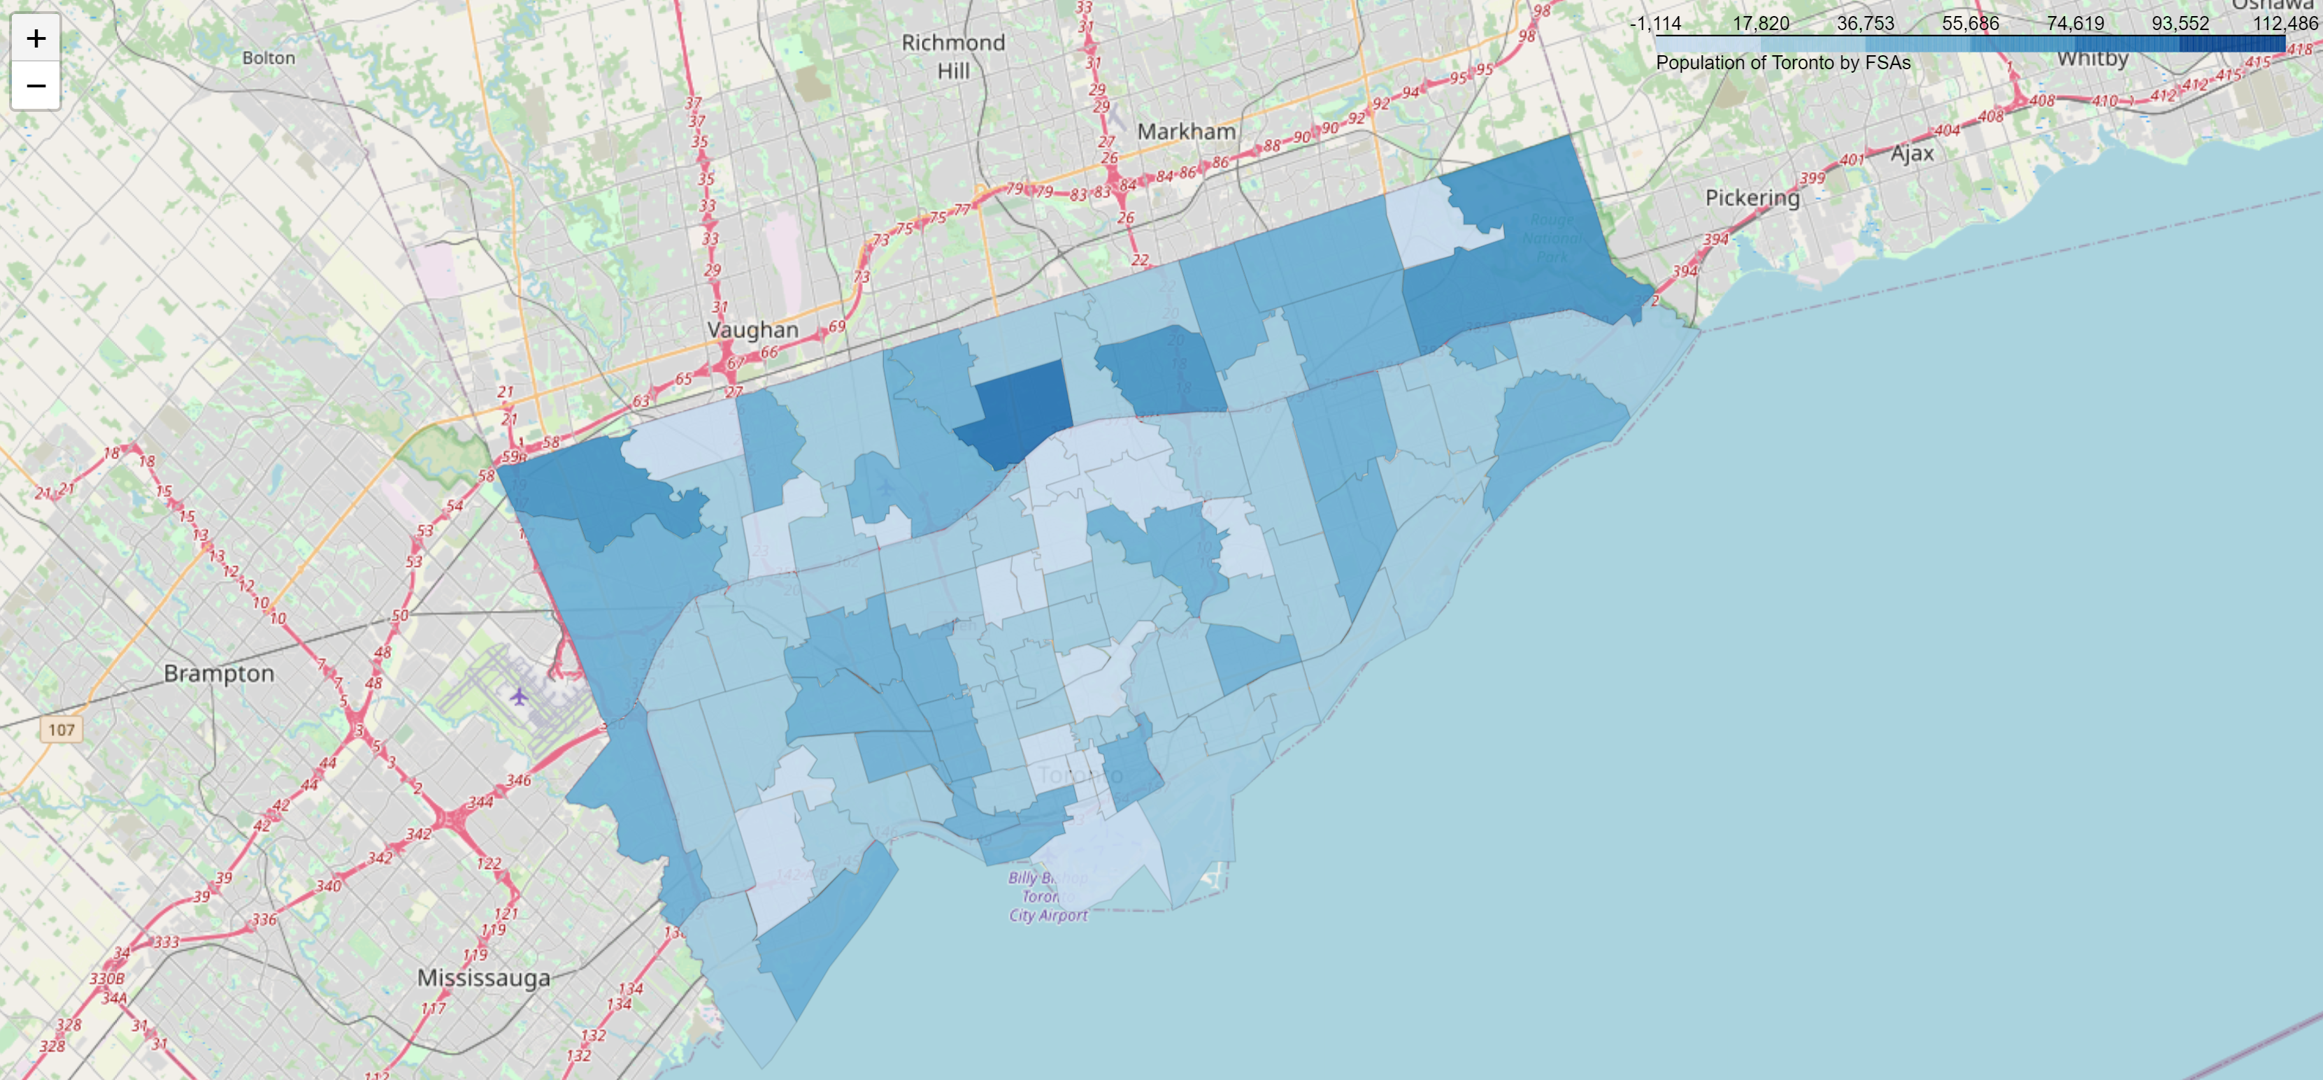

1. We also have a simple look at that distribution of the population in Toronto by FSA code.

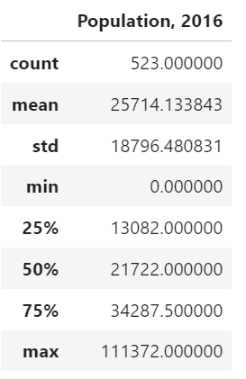

Methodology

Afterwards we based on the onehot encoding dataframe and deploy the k-means clustering technique with scikit-learn. The will help separate neighborhoods in to different group with their restaurant composition.

The first question that come to our mind is the number of clusters that we should be using. To answer this question, we utilize the elbow method can see if it could provide as any clues.

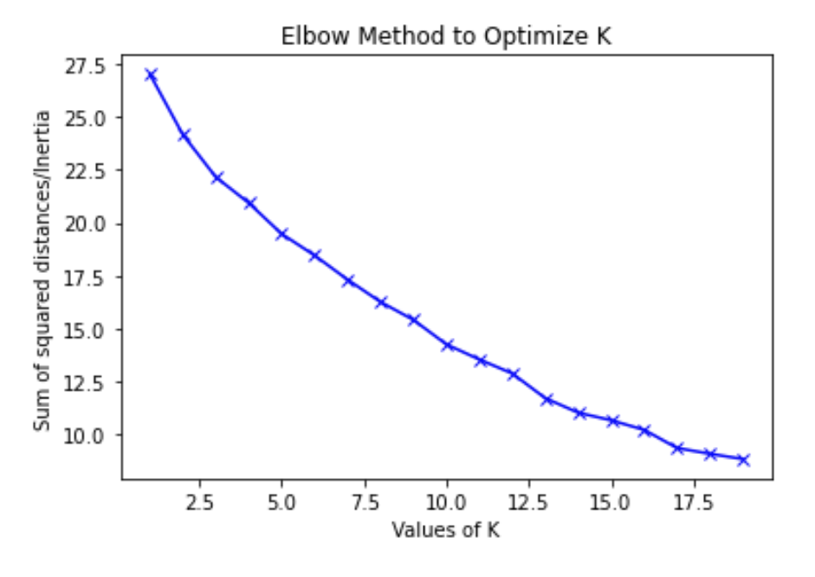

The graph unfortunately does not give out a clear signal as to where the elbow is. And we see a slight turn at K around 16. Hence we will choose this number for our analysis.

After we fit the model with the dataframe we have, we merged the cluster labels with our top 10 common restaurant dataframe and the neighborhoods’ respective postal code and geolocation values.

Next, we create makers on our choropleth map we just created indicating the cluster of neighborhood with their respective cluster color.

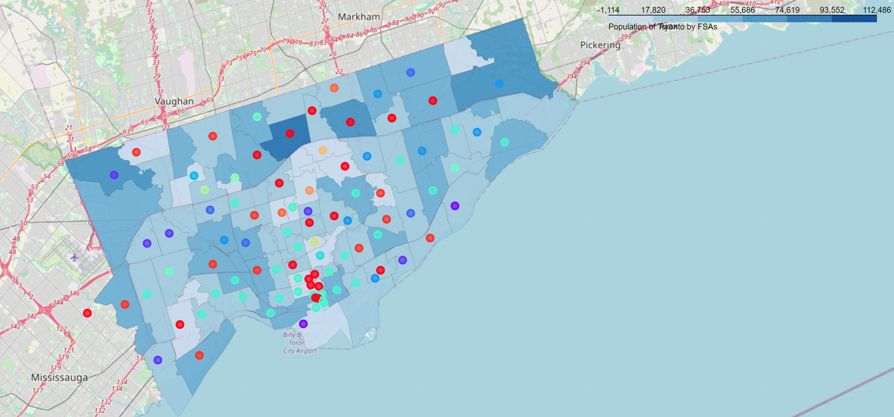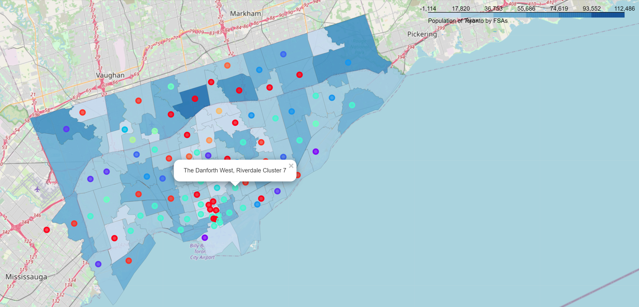

Result

Then, we find out the top 3 most popular clusters.

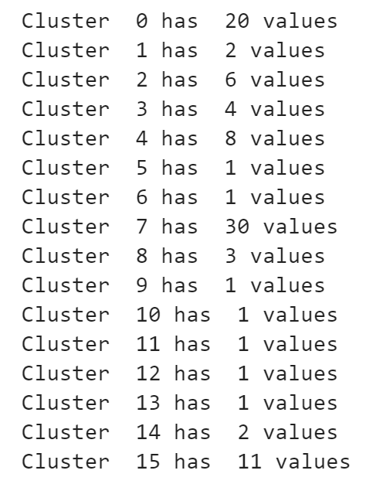

It turns out that cluster 7, 0 and 11 are the ones with most neighborhood included.

Observations

We move on to examine these neighborhood and check for similarity within each cluster. For simplicity, we only focus at the top 3 common restaurants in each cluster.

For cluster 7, we see that café is very popular in those areas. While we look at the top 3 common restaurants, generic restaurants (i.e those without specifying the type of cuisine they serve) are appearing frequently.

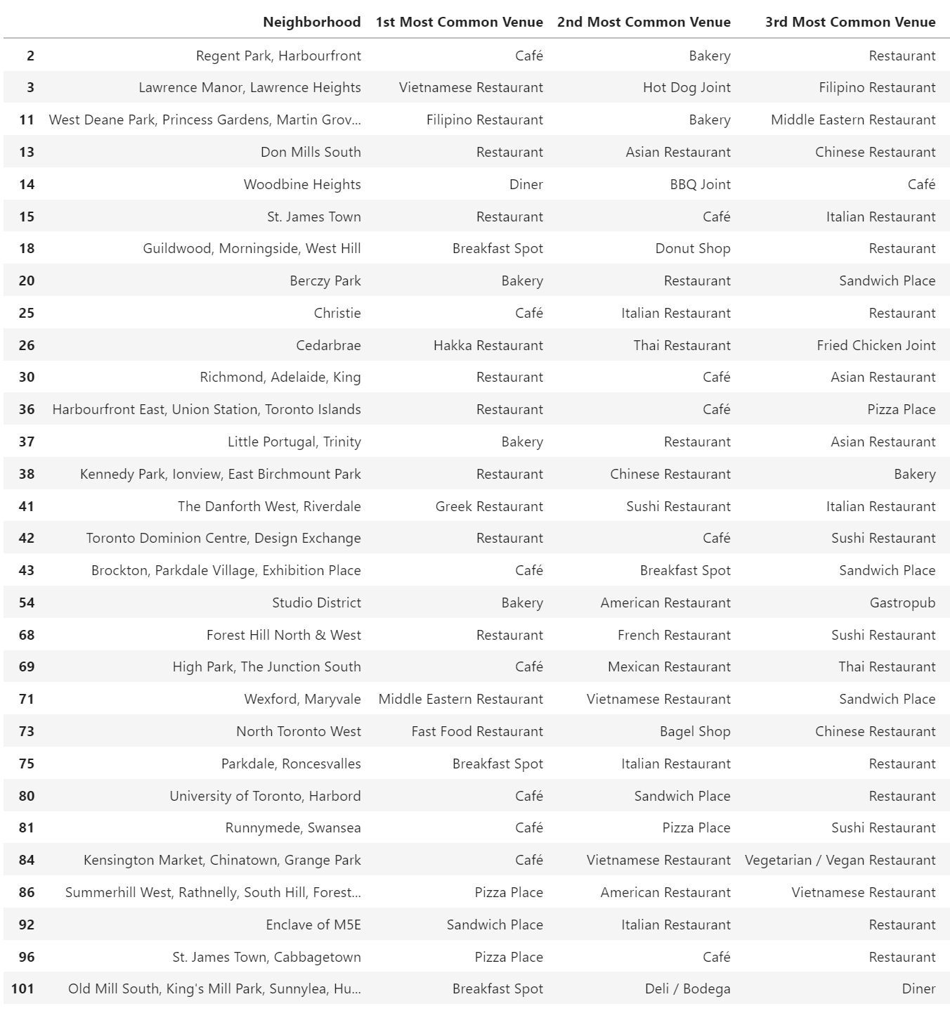

For cluster 0, while café remains very popular, we see that among the top 3 common restaurants, Pizza place and Japanese restaurant stands out.

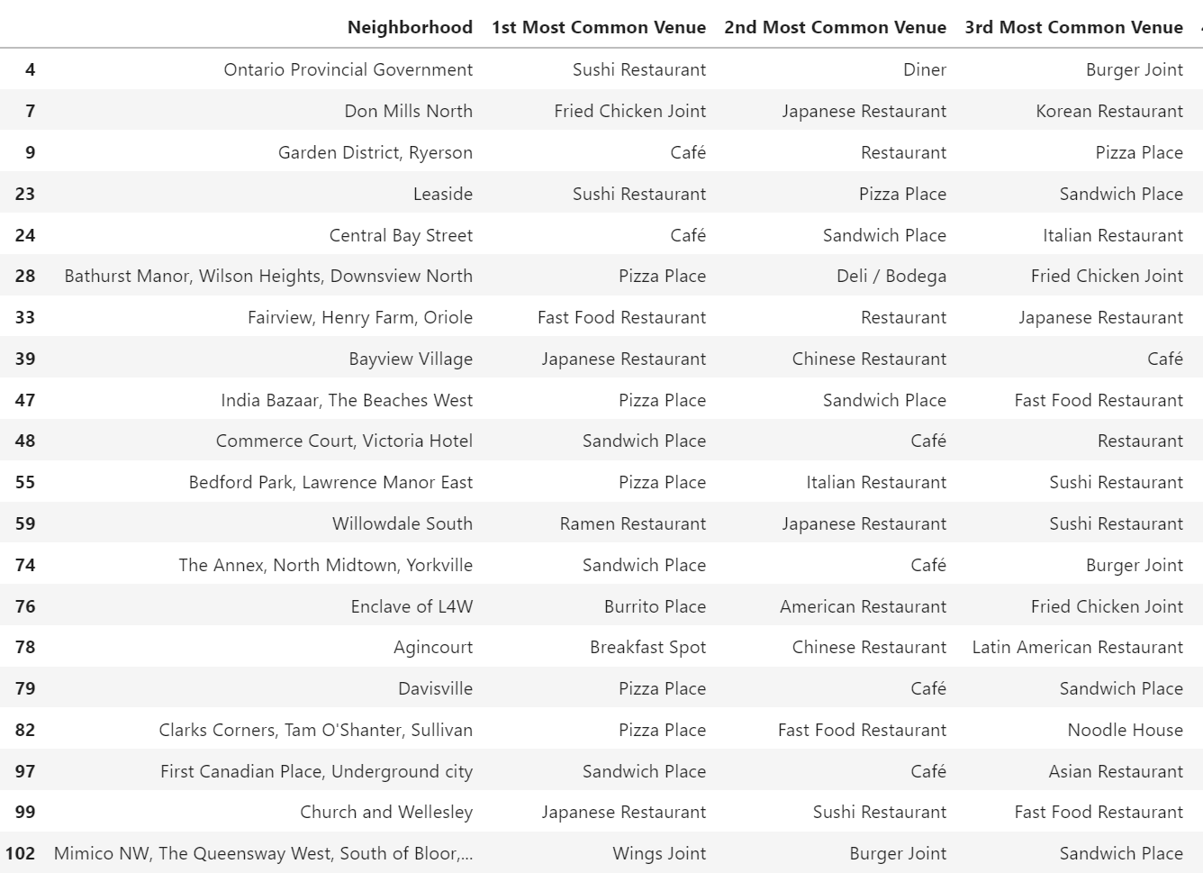

For cluster 15, we see that café become slightly less popular and pizza place become ubiquitous. And Japanese restaurants are less common comparing with cluster 0.

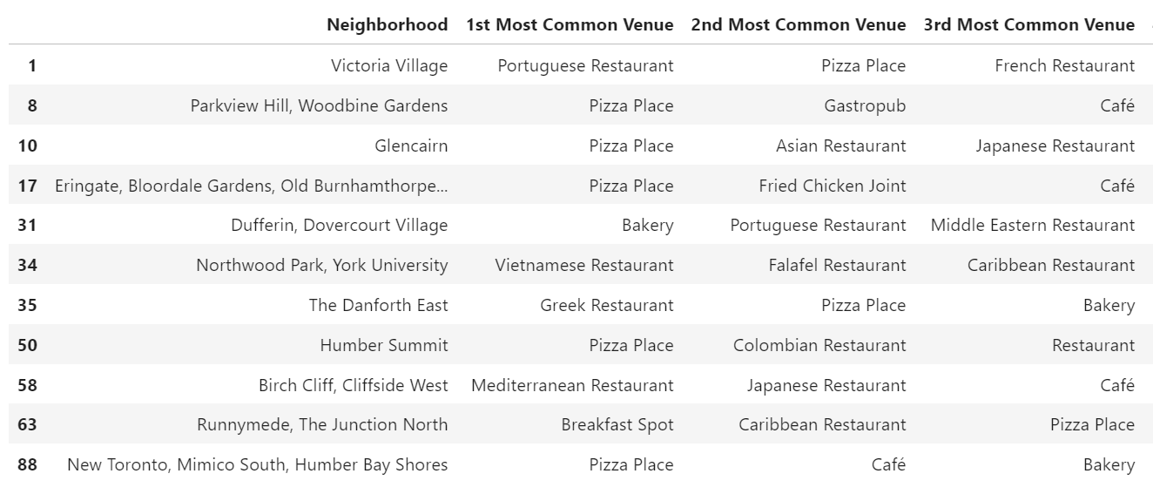

After examining the types of restaurants in the top clusters, we relate the cluster to our population data on the choropleth map to see if we would extract more insightful data to aid our business decision for the restaurant chain operator.

One quite clear observation is that the light blue dots on the map, which indicating cluster 7, a lot of them is located towards the southern part of Toronto and are located in areas with around median population, (recall that the median population in each FSA are is around 21722 which is filled with greenish blue color on the choropleth map.

Looking at cluster 0, the result seems to show that there are more dots located in area with relatively higher population. Indeed, the area with the highest population with a deep blue color filling, willowdale south, is classified as cluster 0. At the same time we also see some area with average number of population denoted as cluster 0.

When it comes to cluster 15, it is almost clear that the cluster locates mainly in areas with population above the 75 percentile.

Discussion

With this simple overlay of popular restaurant type and population per FSA, we might be able to infer and generalize a rule that could help the decision making of the business owner.

Firstly, cluster 7 is the most popular cluster and café and generic restaurant as the most common restaurant type. This cluster also locates mainly in areas with an average number of population. Comparing with the most popular restaurants in Toronto as a whole, which are also café and generic restaurants as shown on the top 20 restaurants chart, this simply reaffirm the prevalence of the two types and its popularity among average Toronto citizens. It could be safe to suggest to the businessman, if he does not want to run a risk, simply follow with the trend to open a café or a generic restaurant in area’s denoted as cluster 7 would mean a safest choose to tap into the market.

What if the businessman wants to try something exotic or specialized? We could consider recommending him to open a pizza place in cluster 0 and cluster 15 or a Japanese restaurant in cluster 0.

Conclusion

This analysis deployed machine learning model and geographic visualization techniques as well as data from Canada’s statistic bureau and Foursquare to narrow down the question of which type of restaurants in which location should a new entrant enter the catering business in Toronto.

We find that café and generic restaurants are the safest choice to operate in most area while pizza place and Japanese may be good options for certain locations.

While the analysis draws this preliminary conclusion in response to the business question, a more in depth analysis with plenty of extra data such as salary, house price, restaurants rating and menu prices can be added to improve the accuracy and depth of the analysis.